**Print Award Program**

**상장 출력 프로그램**

**201601812 Yunboo Shim심윤보**

**201603727 Seongil Heo(허성일)**

**Introduction**

If you specify a list of data and select criteria, you can print out the listing according to the ranking.

**Motivation**

When I was 21, I worked as a staff member at a Dance Concours. There were many participants at the time and the Concours were held in various field such as ballet, modern dance, and Korean dance. After all the Concours, the awards ceremony was held. But problem has arisen. Someone was winners, but their award was not printed. Some others are not winners, but they got it. This happened because a staff was typing and producing it one by one. I thought this problem was caused by the fact that there are currently tools to make the award paper, but it is not easy for non-specialists to use it. I experienced this and felt the need for a award papers production program. So I thought I'd make it.

**Technical Survey**

Currently, the most popular program used to produce the certificate of award is Excel. Excel has the advantage of being easy to manage and arrange data. But it is difficult to design a certificate layout. To print out a designed certificated of award, you need to use a different program. Also people who are not good at Excel have trouble using it. In addition to Excel, there are several programs and they are all simple program.

**Need and Effect**

You can enter a large amount of information by receiving people’s information directly or by can

typing in txt file at once. And you can sort these data and see the sorted results. Finally you can

create various layouts to gain the diversity of design layout. All of this process can be solved by one program

**Design**

**-** It consists of five screens. First is Menu selection screen. Here you can connect to the next to the screen. Next screen is data entry screen, data viewing screen, choose layout design screen and output screen.

-When you choose data entry screen, you input name, field and score directy. Field information can be selected or entered directly.

-When you click data viewing screen, you can see all participants. If you want to sort by name. You can click on the “Name” button. Field and scores too.

-When you click design screen, you can see various images of certificate of award. You can choose the design you want.

-Finally, if you click output screen, you can select the field to print. But if you do not want to something, you can click checkbox next to the name area. And then click “Print” button.

-Refer to the picture below.

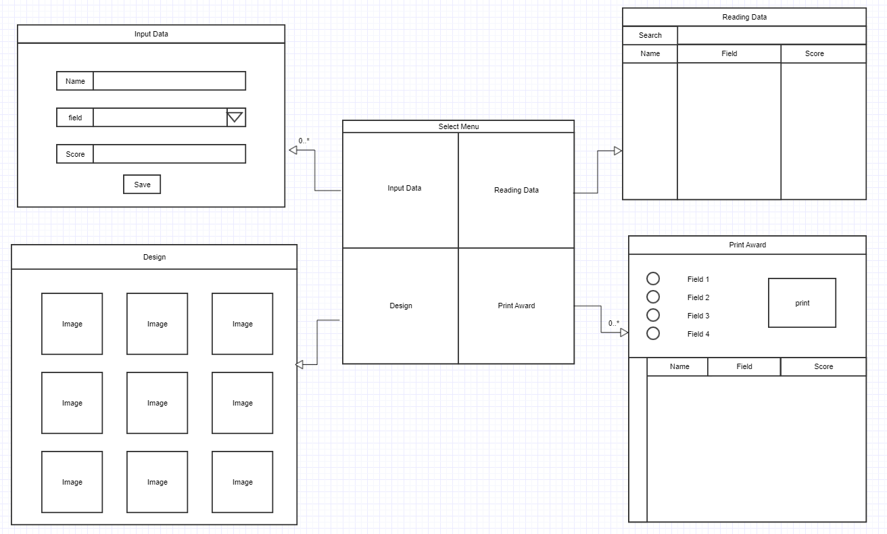

‘;

**Methodology**

**data input output**

We make a bundle of personal information such as ‘name’, ‘field’, ‘score’ into class. And we use this as a data type of downcasting, arraylist.

We will input personal information directly or use the stream to input in the text files.

In order to show datas, we have to alignment. So we will use the Collections.sort() method to align.

At the end of the output, a stream is attached to the document completed in the pdf file.

**GUI**

The first screen consists of four buttons and labels so we will use Gridlayout defined by two rows and two columns and JButton, JLable. In the input data display, we will use JLabel and JTextFile, JMenu, FlowLayout, JPanel. We will input name, score using JTextFile. We will use event handlers to activate the button when we press it and will use JPanel to fasten the component area. In the Reading data display, we will use FlowLayout and JPanel as above. we will search the name using JTextfile , will appear to the stored data using JTable. In the Design data display, we will consists of title system area and image area using JLabel. We will use FlowLayout in the Print Award data display, we will the configure the display using

JCheckbox,JButton,JLabel,JTable and FlowLayout.